Multimedia Web Design Homework
HTML EXERCISES (week 5)
Styling Your Portfolio — From Zero to Beautiful

Eda Selmani – Computer Engineering

Exercise 1: Link CSS and Write Your First Rules
- Create a new file called style.css in the same folder as your index.html.
- Add the <link> tag inside your <head> in index.html.
- In style.css, write a rule for body that sets: background-color to #F0F4F8, margin to 0, and font-family to Arial, sans-serif.
- Write a rule for h1 that sets color to #1E3A5F and text-align to center.
- Write a rule for p that sets font-size to 16px and line-height to 1.6.
- Save both files and refresh your browser — you should see the page transform instantly!
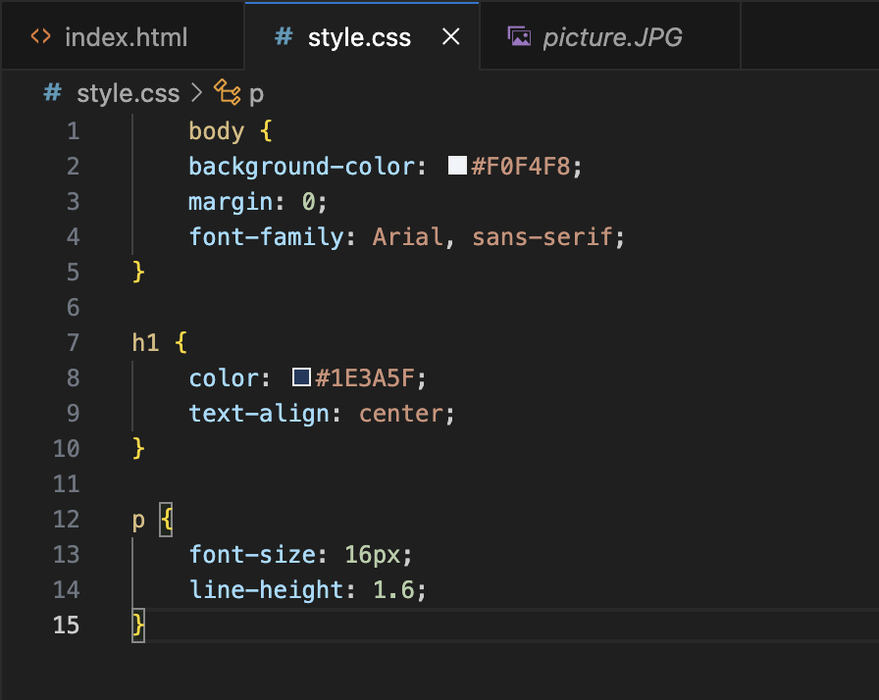

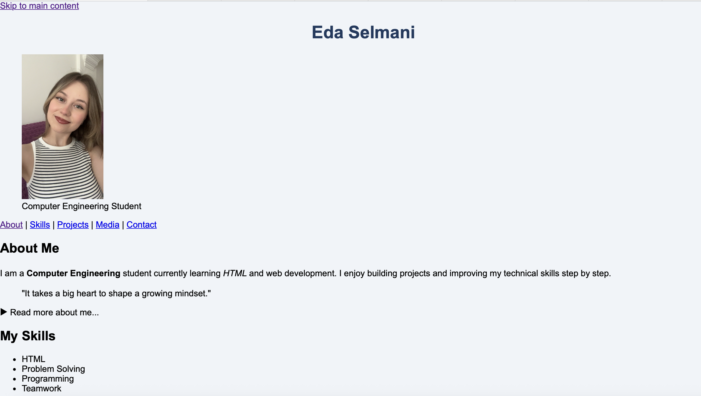

Exercise 2: Style Your Portfolio with Multiple Selectors
- Add a class selector .section-title that makes text uppercase, adds a bottom border in a color of your choice, and adds padding-bottom: 8px.
- Apply that class to all your <h2> tags in index.html using class='section-title'.
- Use a pseudo-class: make all <a> links change color on :hover.
- Use an attribute selector: style input[type='text'] and input[type='email'] to have a border: 1px solid #ccc, padding: 8px, and border-radius: 4px.
- Use :focus on inputs to add a blue border-color and subtle box-shadow.
- Use tr:nth-child(even) to give alternating rows in your projects table a light gray background.

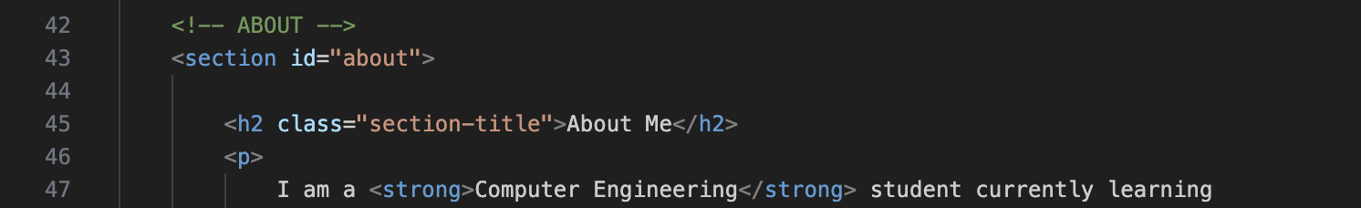

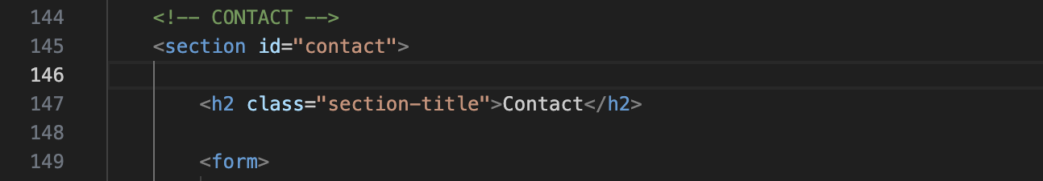

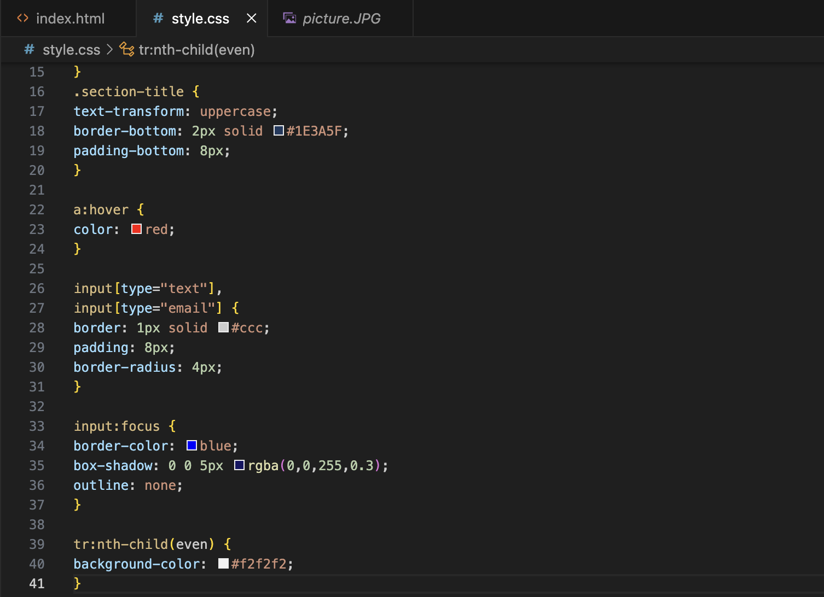
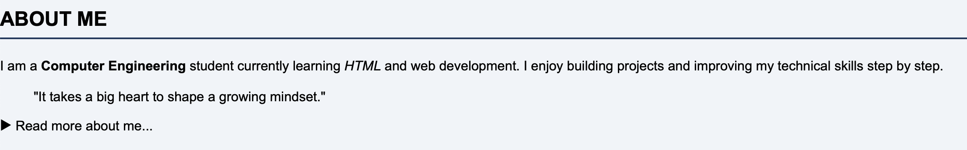
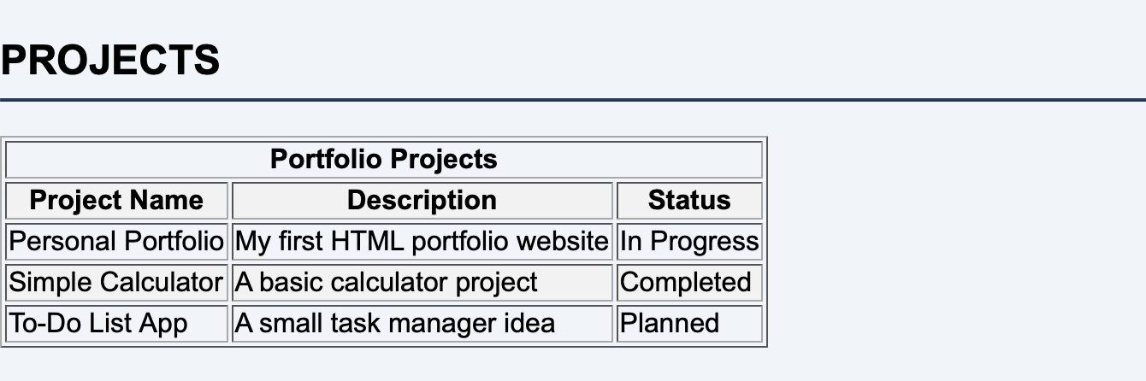
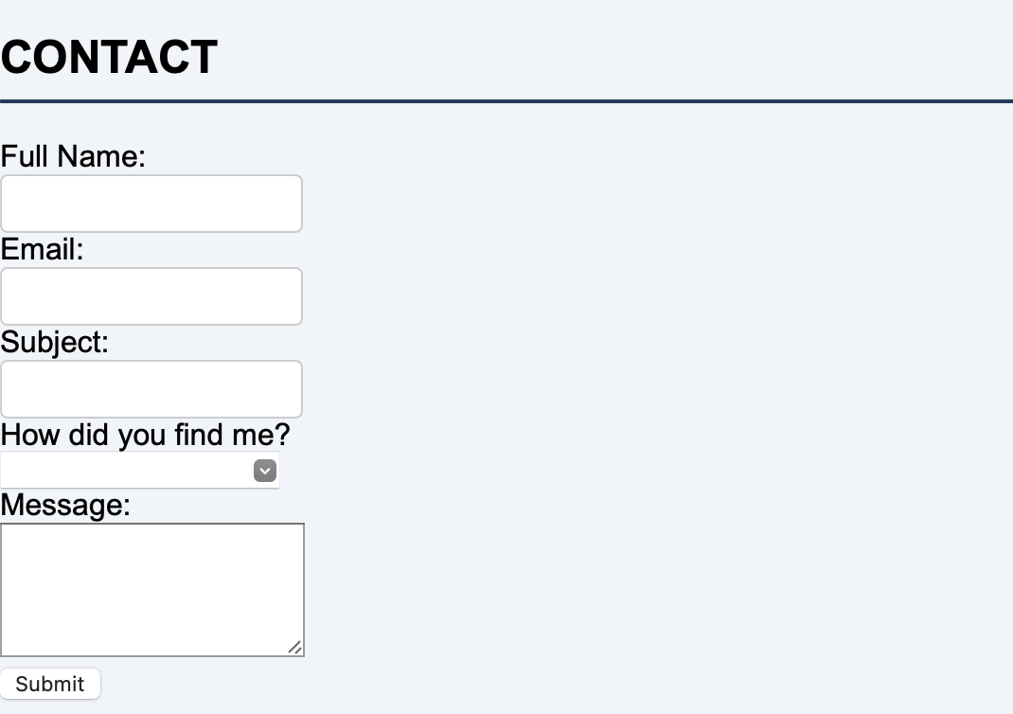
Exercise 3: Define a Color Palette for Your Portfolio
- At the TOP of style.css, add a :root block with at least 5 CSS variables: --color-primary, --color-secondary, --color-accent, --color-text, --color-bg.
- Update all your existing color rules to use var() instead of hardcoded colors.
- Give your <header> a stunning background using linear-gradient with your primary and secondary colors.
- Give your <footer> a background-color using your primary color, and make the text white.
- Give alternating <section> elements different background-colors.
- Add a background-color with RGBA transparency to one element.
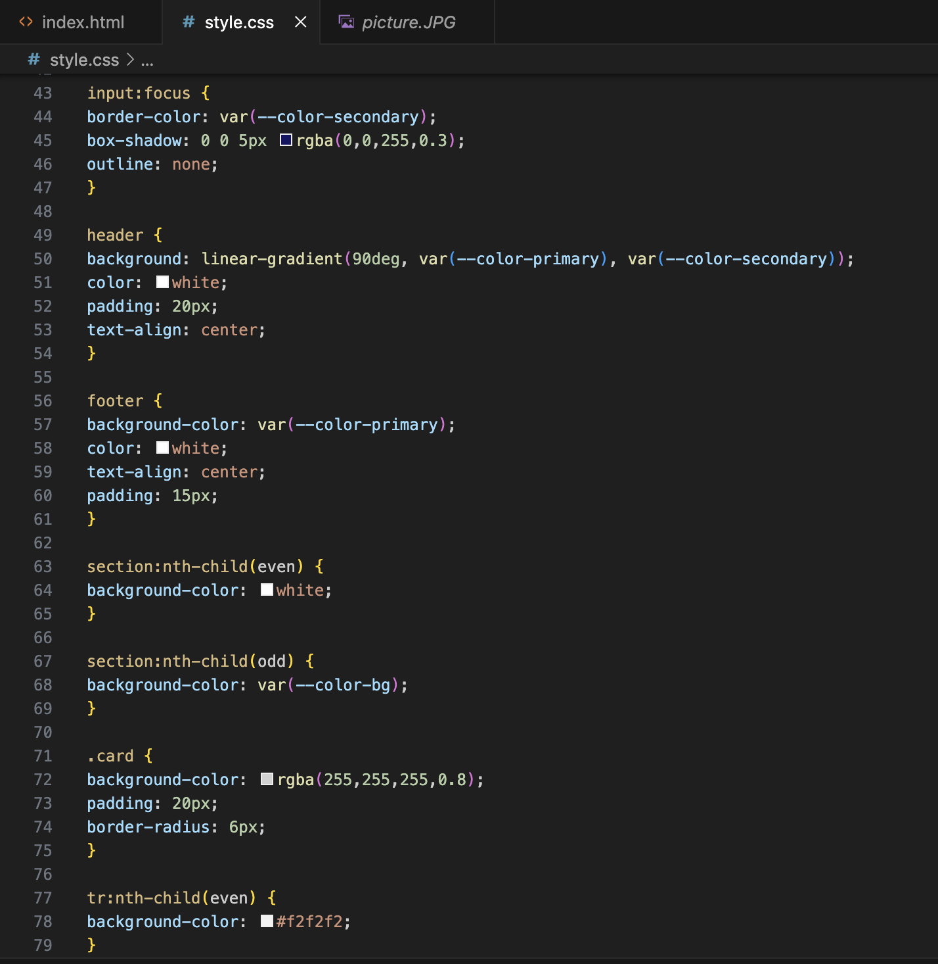

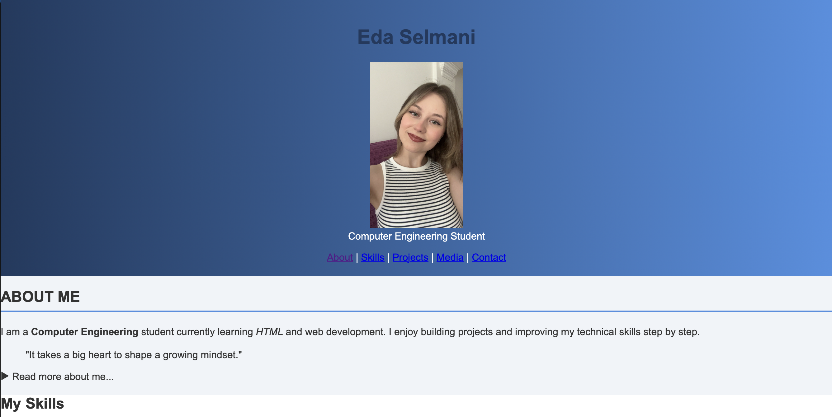
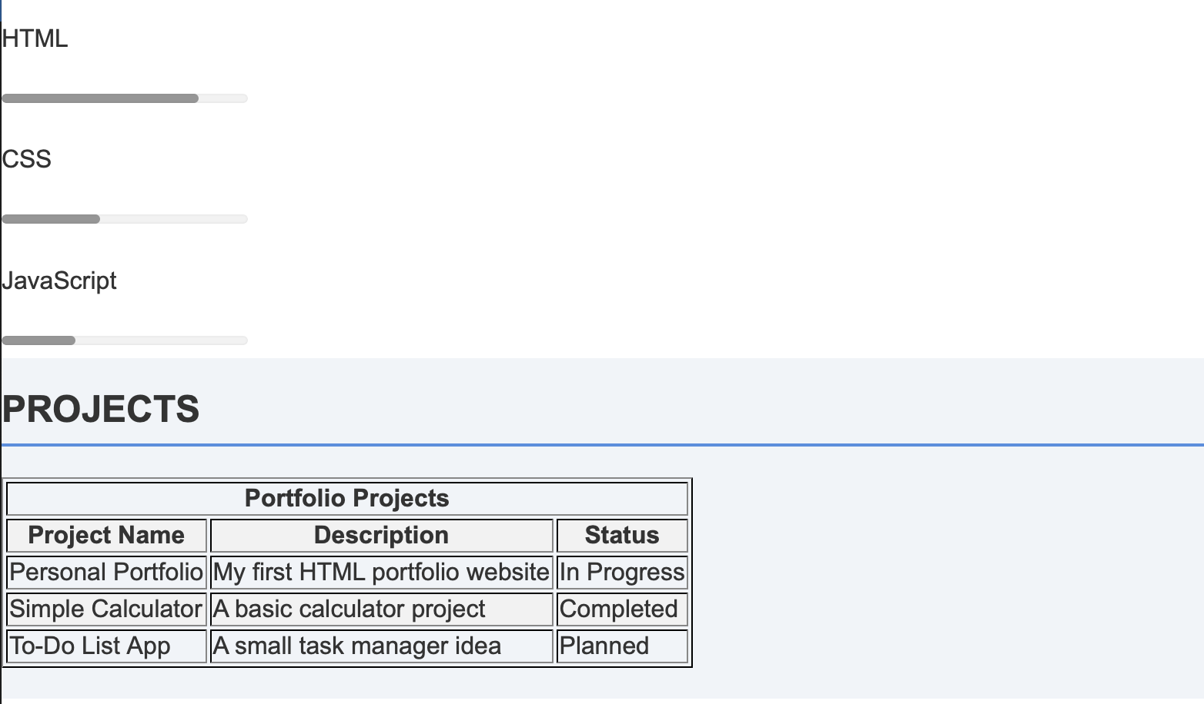
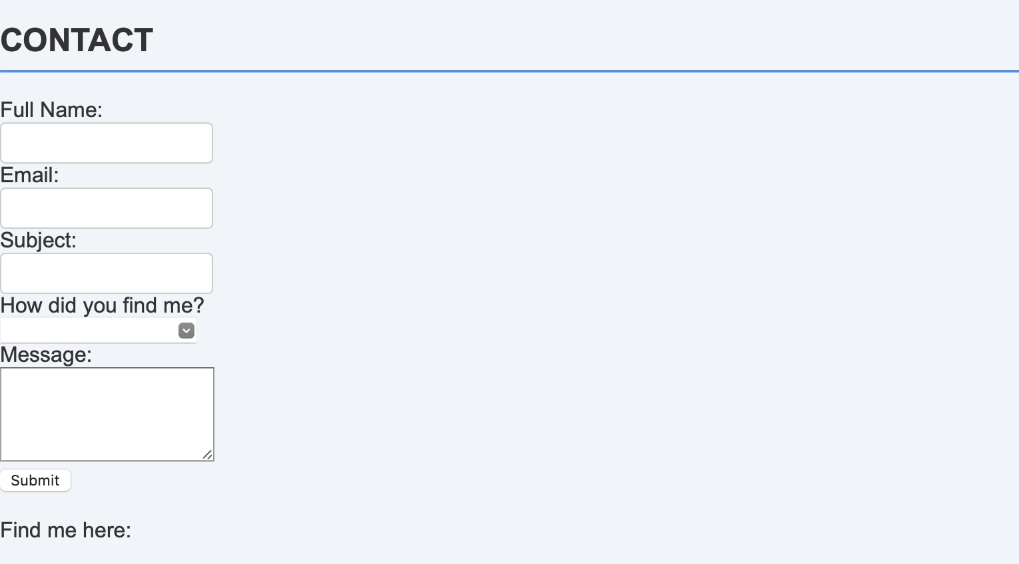

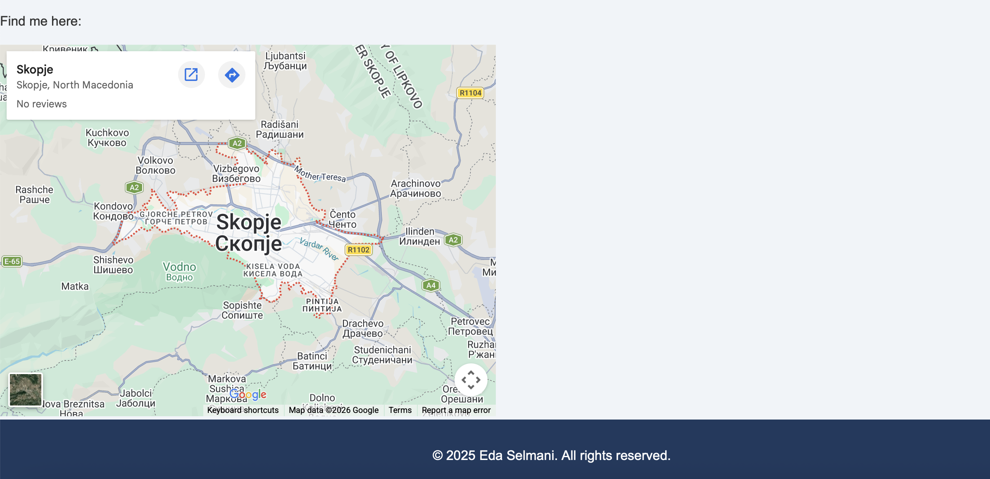

Exercise 4: Style Your Portfolio Typography
- Go to fonts.google.com and choose TWO fonts — one for headings, one for body text. Add the Google Fonts <link> tags to your HTML <head>.
- In style.css: set your body to use your body font. Set h1, h2, h3 to use your heading font.
- Set the root font-size on html to 16px. Use rem units for all font sizes (h1: 3rem, h2: 2rem, h3: 1.5rem, p: 1rem).
- Set line-height: 1.7 on your body text for great readability.
- Add letter-spacing: 2px and text-transform: uppercase to all h2 elements.
- Remove the underline from all links with text-decoration: none. Add it back only on :hover.
- Add a text-shadow to your h1.
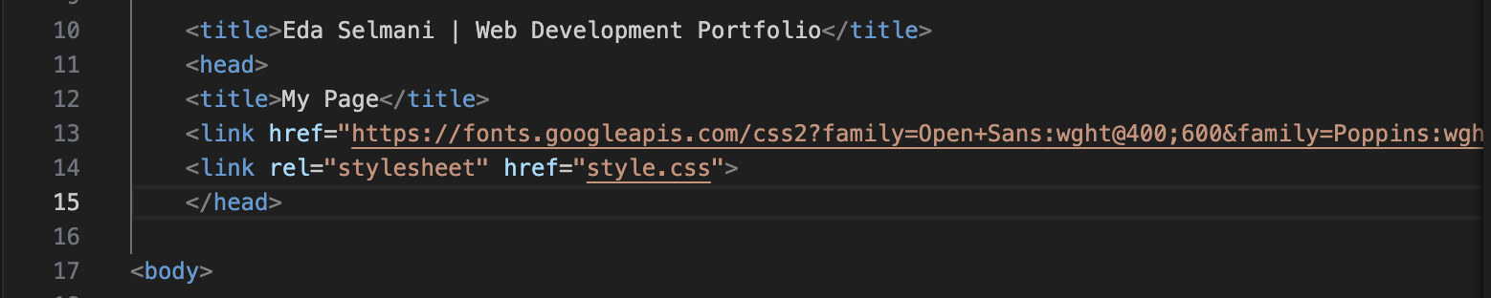
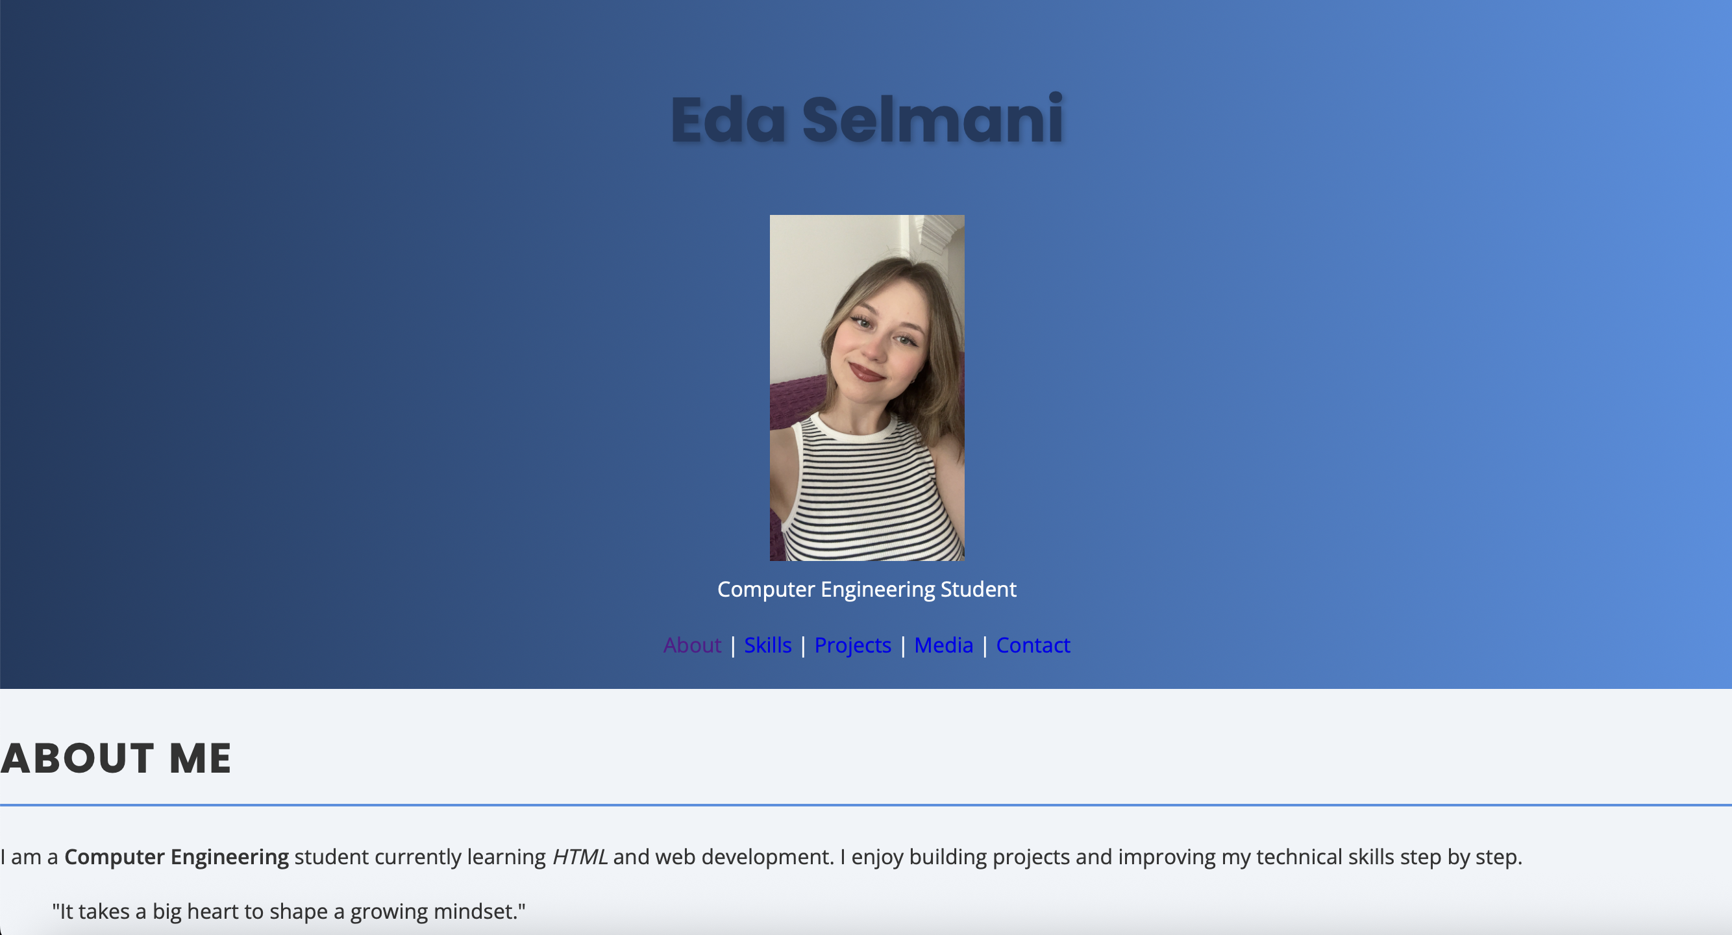
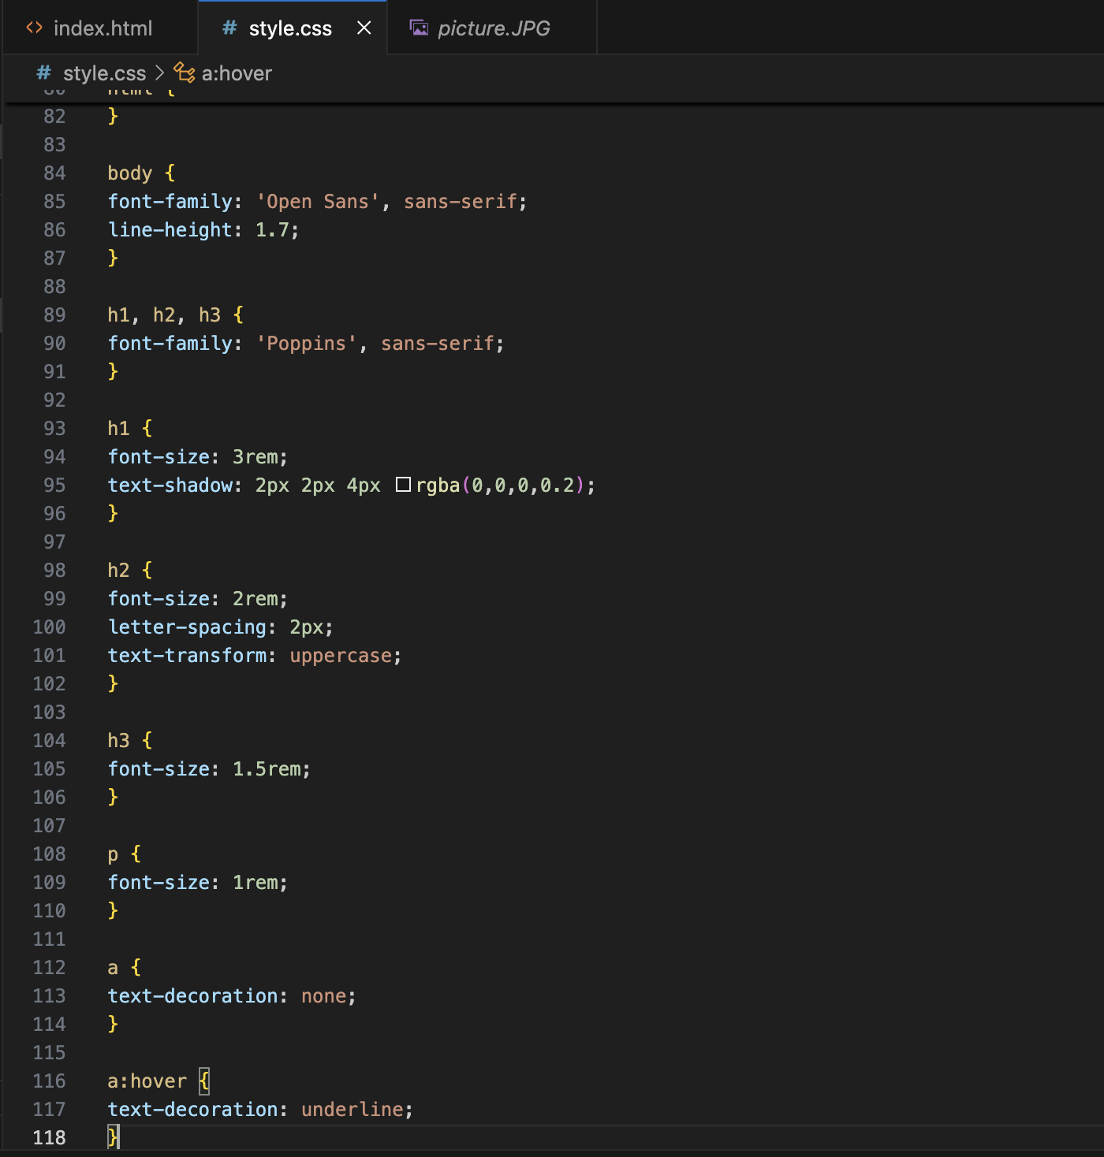
Exercise 5: Style the Box Model of Your Portfolio
- At the very TOP of style.css, add: *, *::before, *::after { box-sizing: border-box; margin: 0; padding: 0; }
- Create a .container class with max-width: 1100px, width: 90%, and margin: 0 auto. Apply it to wrapper divs inside each section.
- Add padding: 80px 0 to every <section> so they have vertical breathing room.
- Style your <header>: padding: 60px 20px, text-align: center.
- Add a border-radius: 8px to your projects table.
- Add a border-left: 4px solid var(--color-accent) to your <blockquote> with padding-left: 20px.
- Give each <section> a bottom border with a light color to visually separate them.
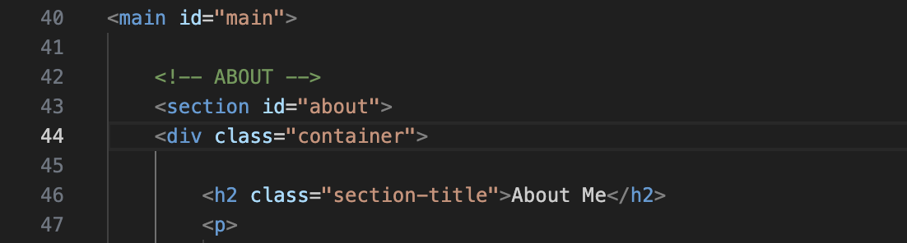



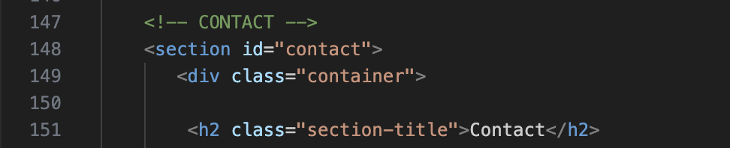

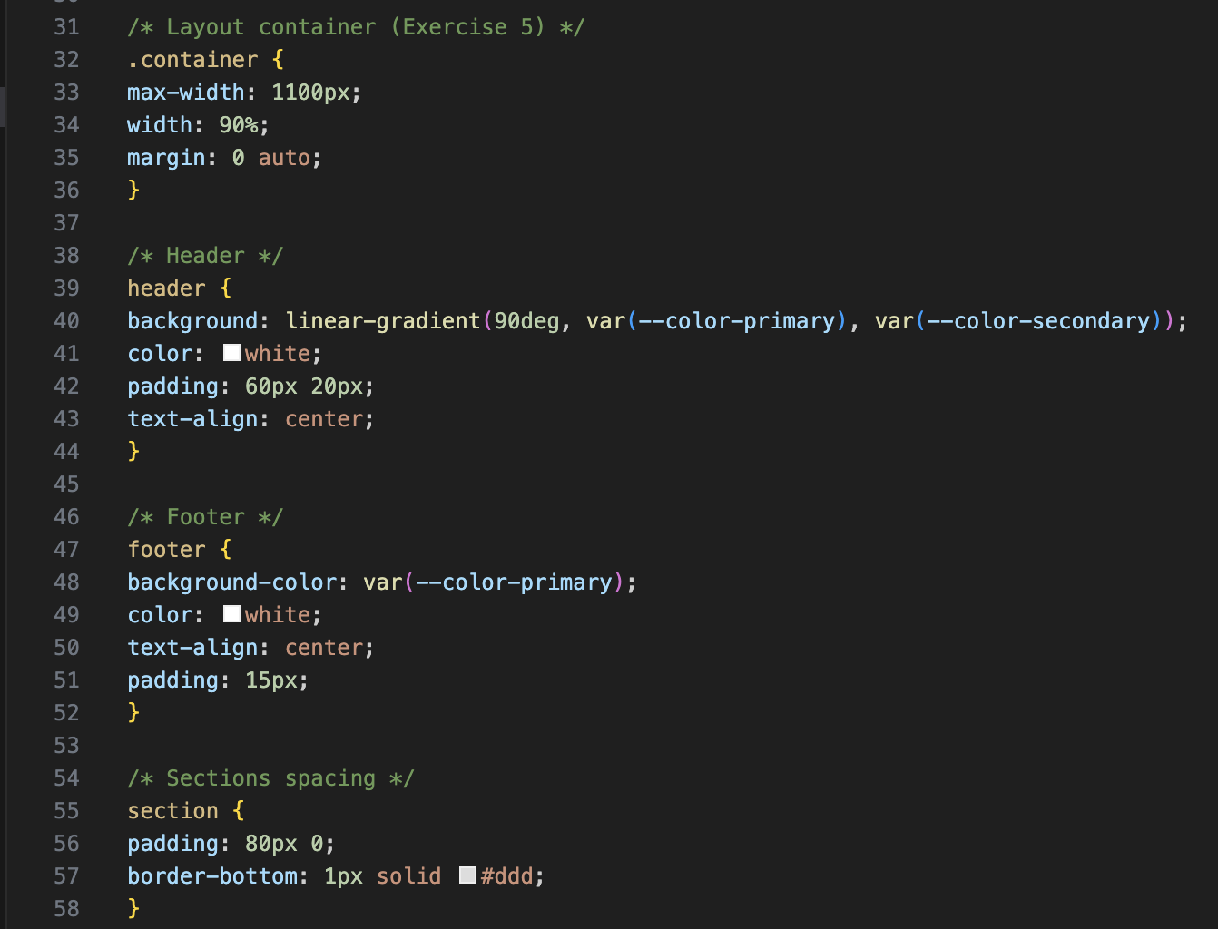
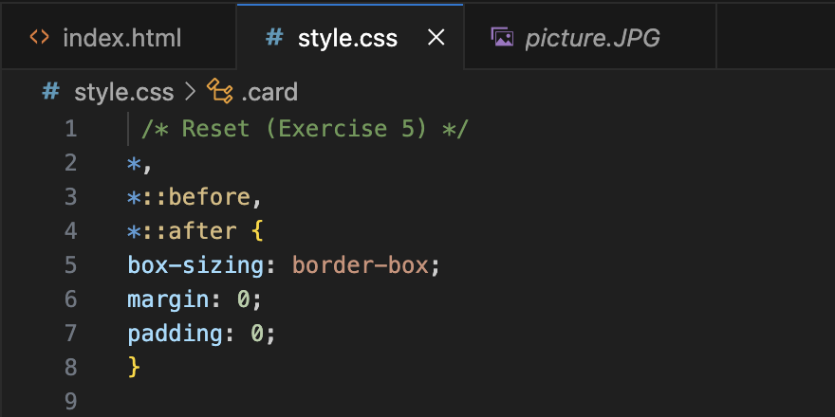

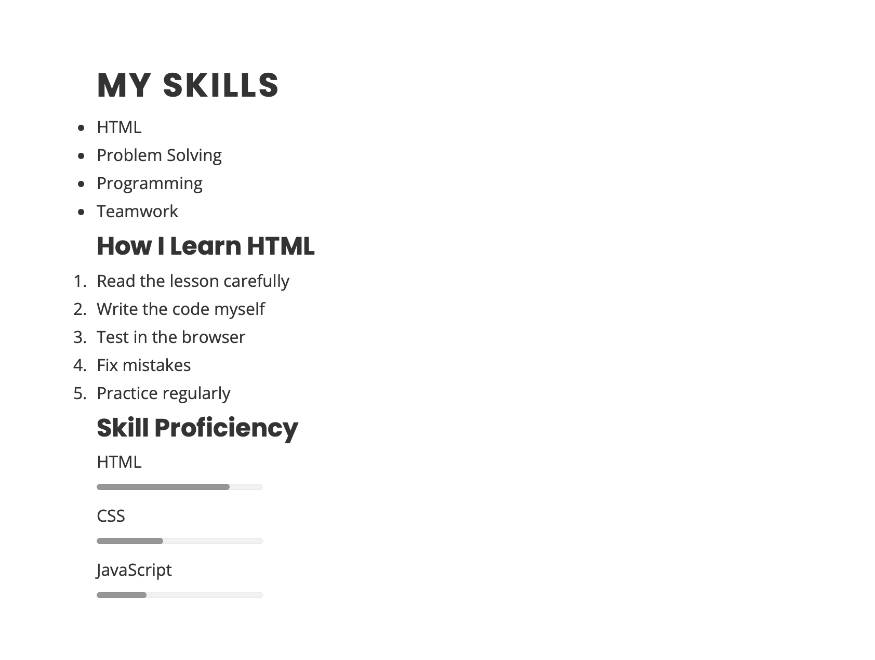

Exercise 6: Debug Your Portfolio CSS
- Open DevTools (F12) on your portfolio page. Look through the Styles panel for any strikethrough or warning rules.
- Check that every rule in style.css has matching opening and closing curly braces.
- Check that every declaration ends with a semicolon.
- Validate your CSS at jigsaw.w3.org/css-validator. Fix any reported errors.
- Look for typos in property names (colour vs color, backround-color vs background-color).
- Fix any identified errors and re-validate until you get 'No errors found'.
- In Exercise 6, I checked my CSS for syntax errors, missing brackets, and incorrect properties. I validated the stylesheet and confirmed that the webpage displays correctly without any CSS errors.

Exercise 7: Add CSS Counters to Your Portfolio
- Add a numbered skills list to your portfolio's skills section using counter-reset and counter-increment instead of an HTML <ol>.
- Style the counter with a bold color that matches your portfolio's accent color.
- Try adding a counter to your project section headers (Project 1, Project 2, etc.) automatically.
- BONUS: Create a nested counter for sections and subsections in your portfolio.
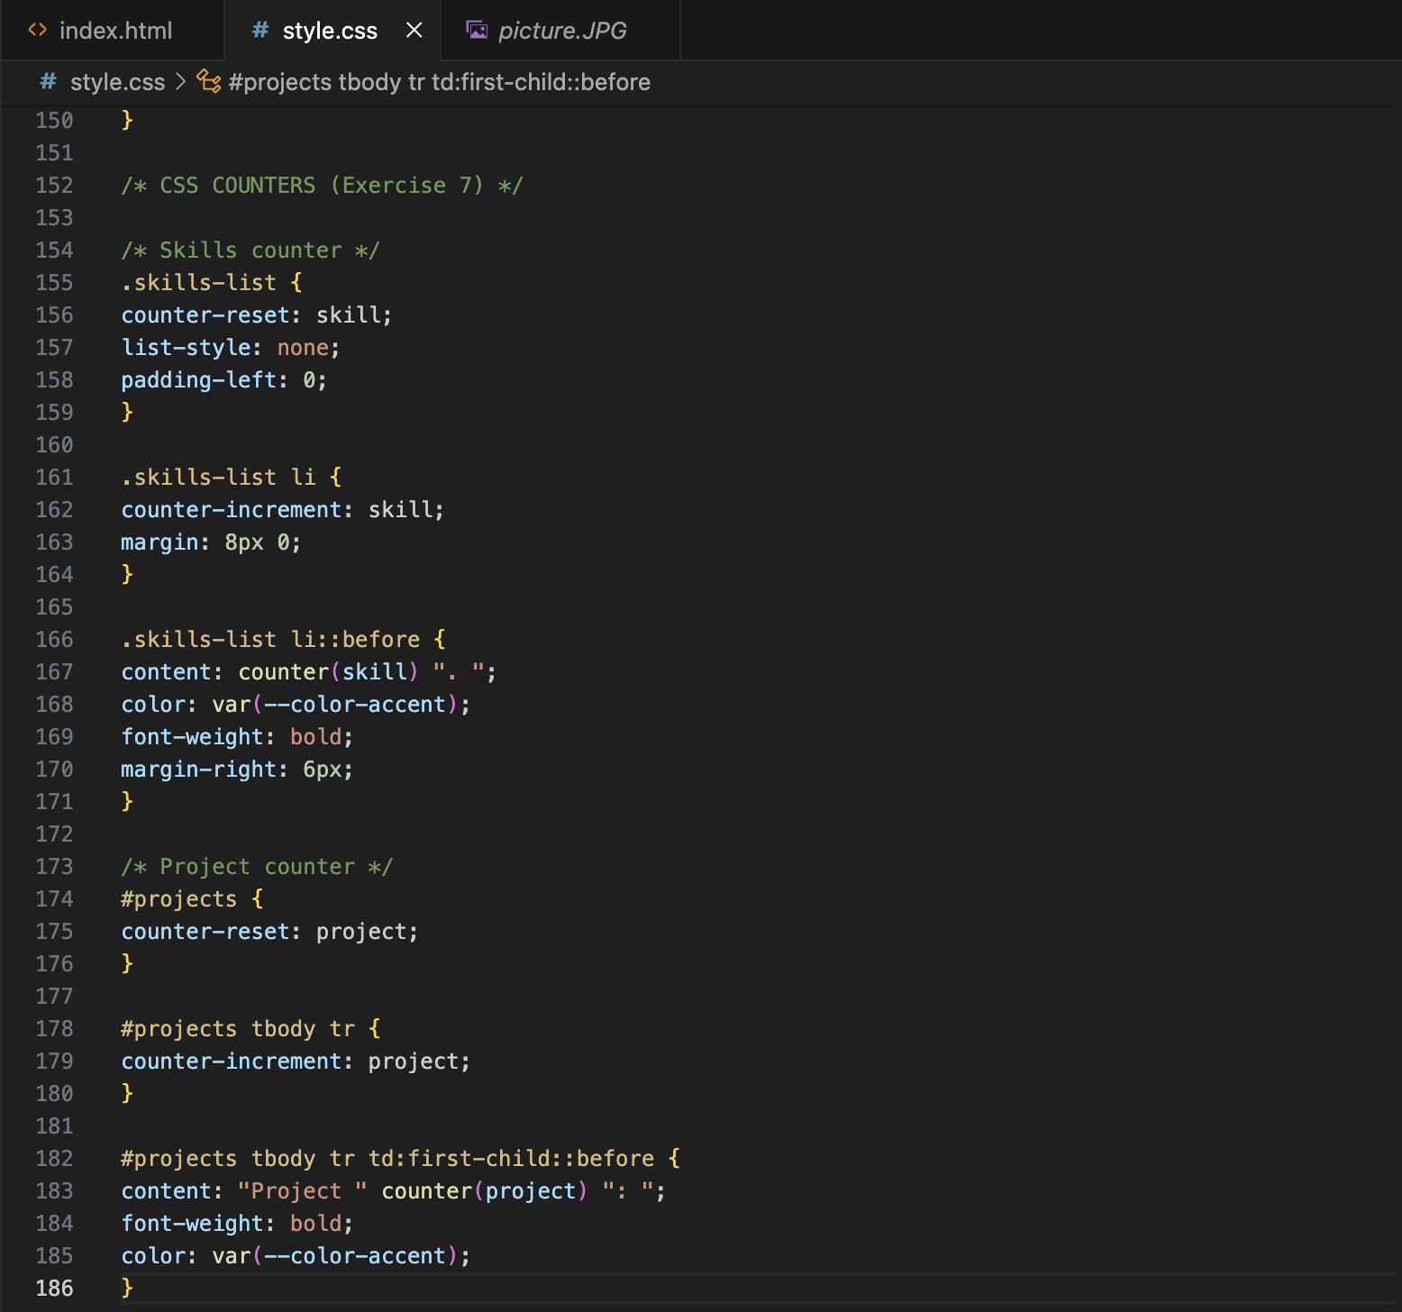
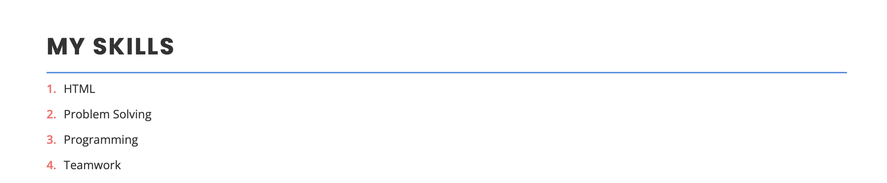

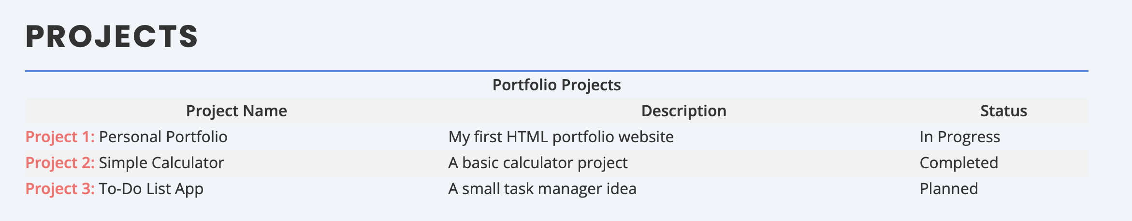
-I implemented CSS counters to automatically number the skills list and project items using counter-reset and counter-increment. The counters are styled with the portfolio’s accent color and displayed using the ::before pseudo-element.
Exercise 8: Master Specificity in Your Portfolio
- Open DevTools and find an element where a rule is being overridden (strikethrough). Identify which rule is winning and why (higher specificity? later in file?).
- Create a utility class .text-center { text-align: center; } and apply it to a heading. Notice it overrides the element rule.
- Try changing a color using a class selector versus an element selector — see which wins.
- Find a place in your CSS where you can remove a duplicate rule now that you understand the cascade.
- BONUS: Refactor any use of !important in your CSS to instead increase specificity naturally.
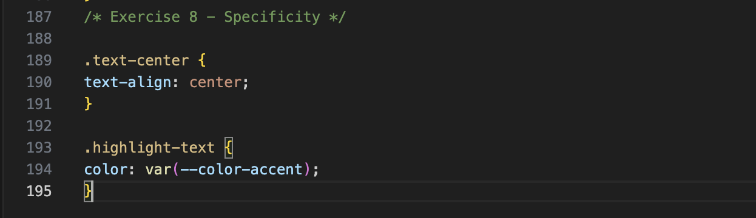
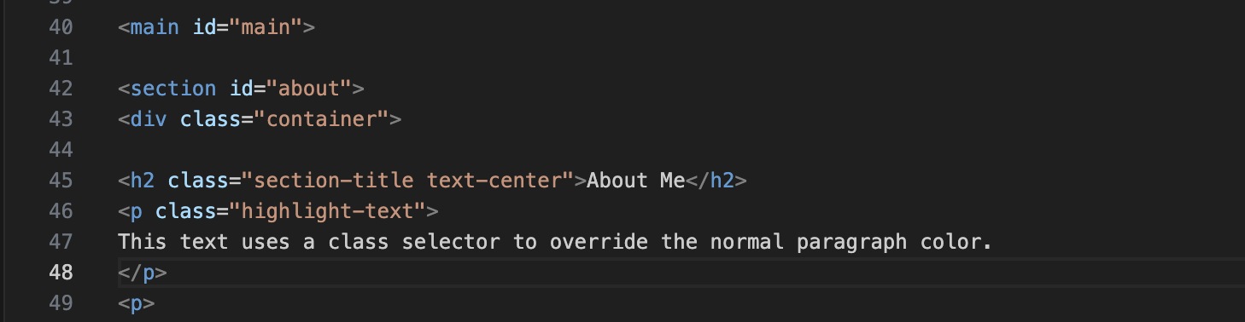
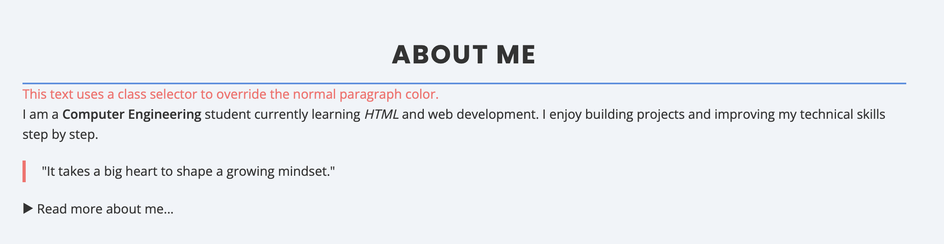
-I tested CSS specificity by applying a class selector to override an element selector. The .highlight-text class changes the paragraph color, demonstrating how class selectors have higher specificity than element selectors.
Exercise 9: Use CSS Math in Your Portfolio
- Replace your h1 font-size media queries with a single: font-size: clamp(1.8rem, 5vw, 3.5rem); — resize the browser to see it scale fluidly.
- Use calc() to set your main content padding-top to account for your sticky header height: padding-top: calc(80px + 20px).
- Use min(500px, 100%) on your profile photo to prevent it overflowing on small screens.
- Use clamp() for your h2 and p font sizes too.
- BONUS: Define --nav-height: 80px in :root and use calc(var(--nav-height) + 20px) wherever you offset for the header.
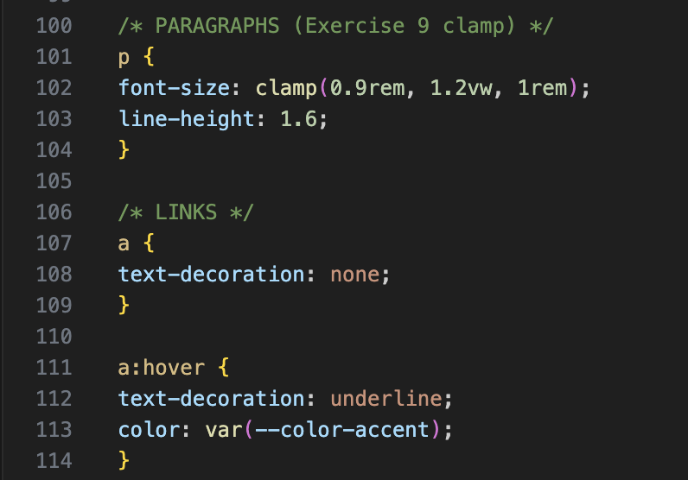
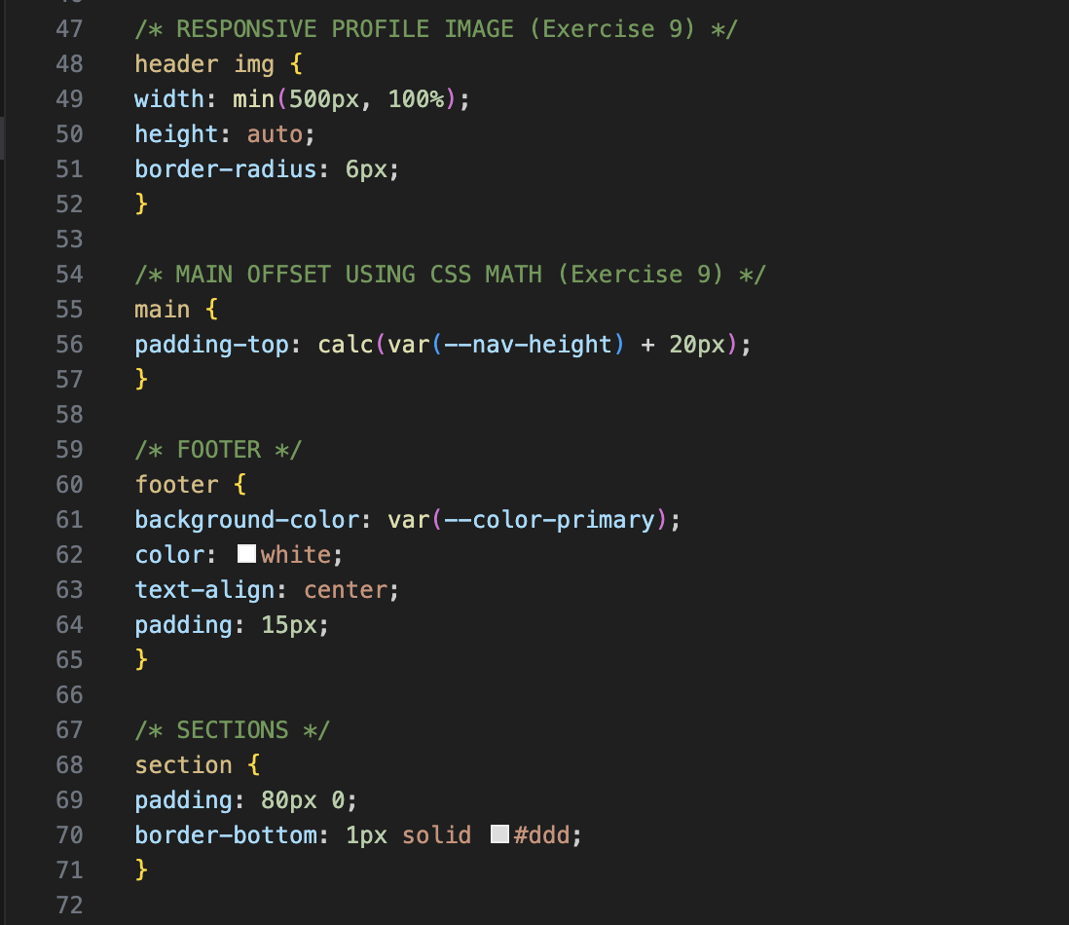
I used CSS math functions such as clamp(), calc(), and min() to create responsive font sizes, adjust layout spacing, and ensure the profile image scales properly across different screen sizes.
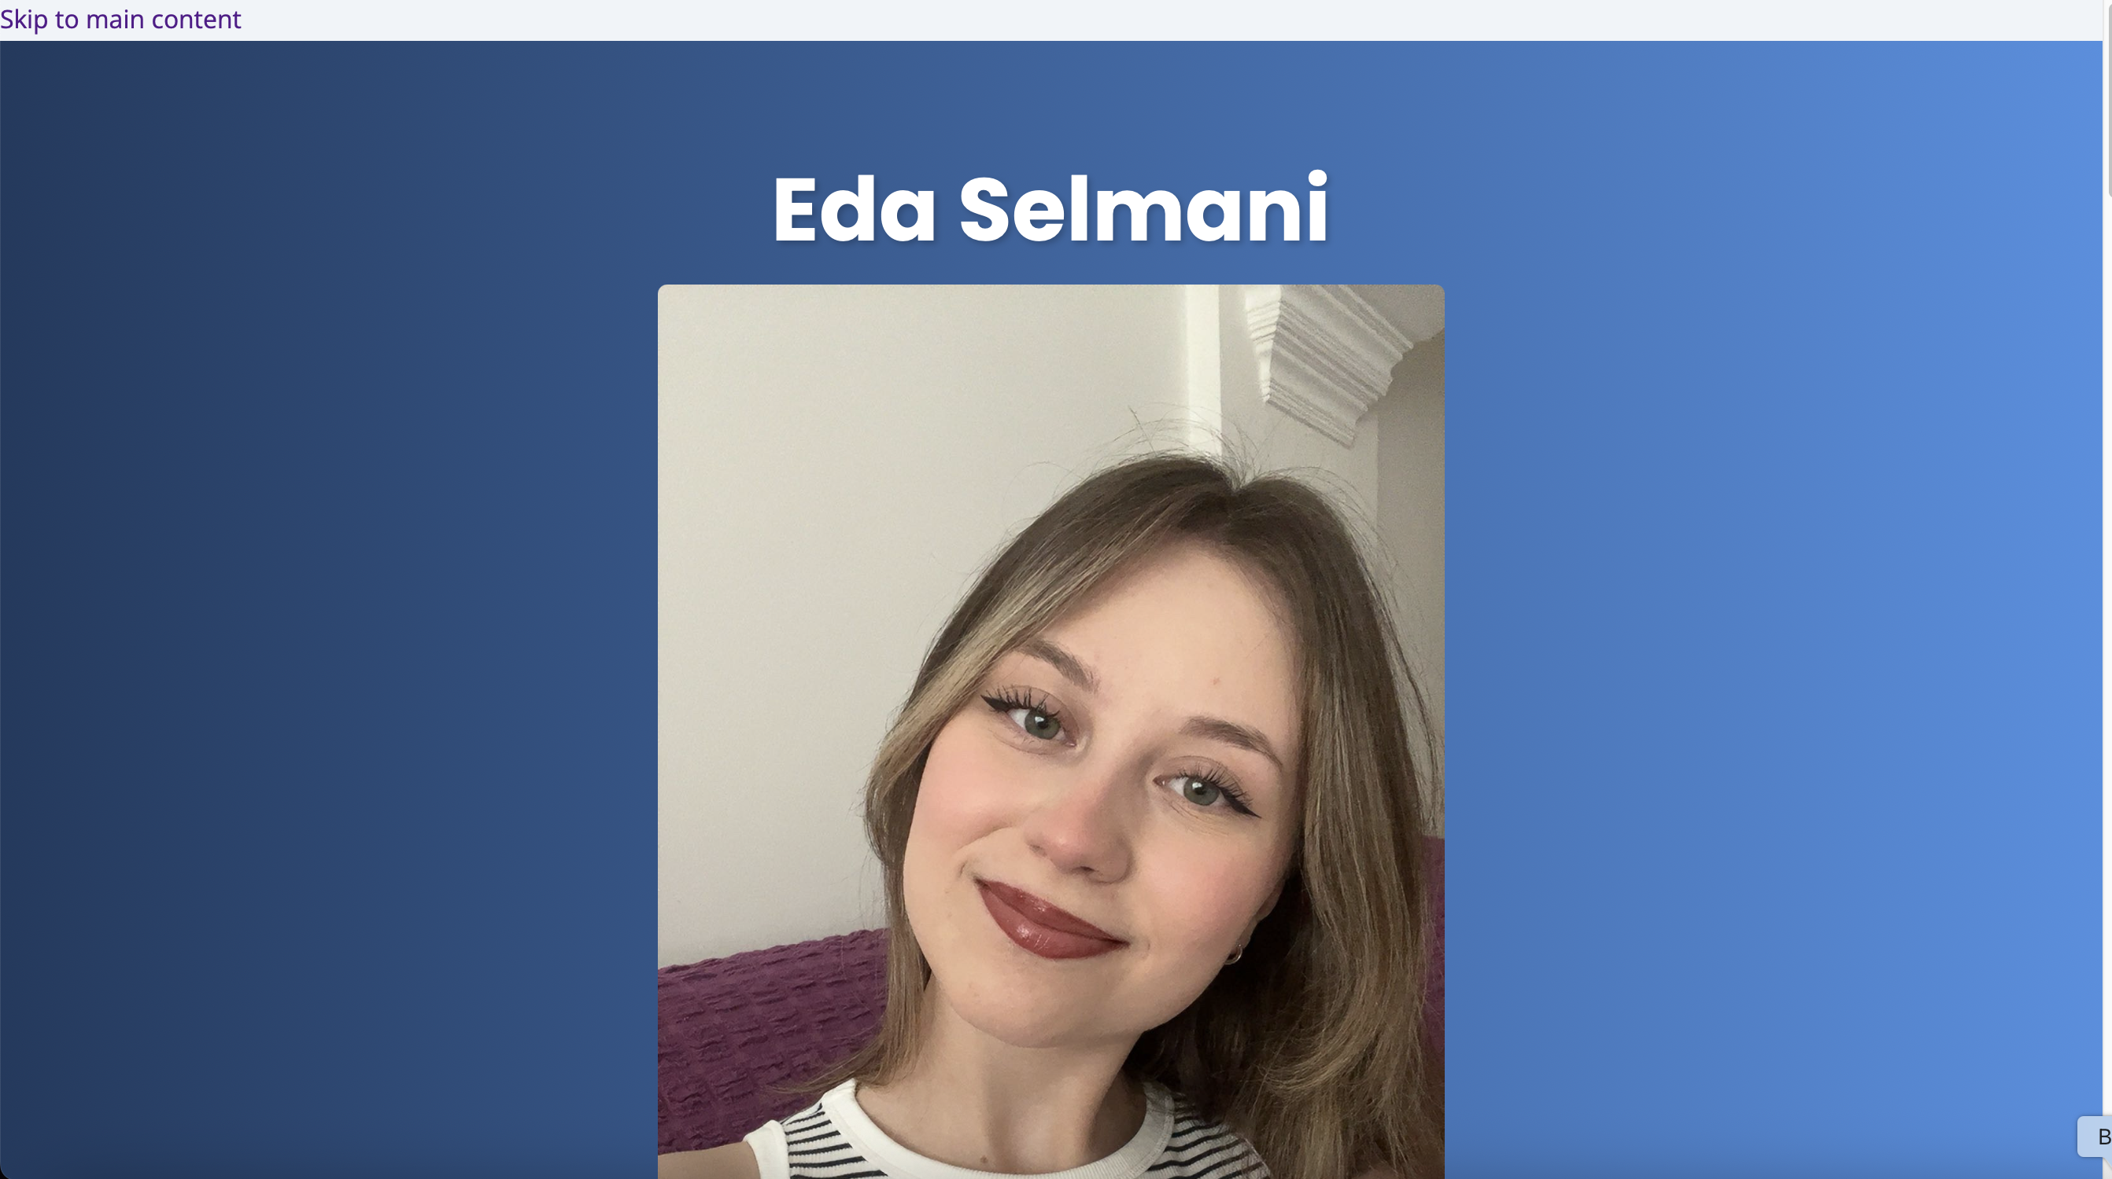
Exercise 10: Optimize Your Portfolio CSS
- Review style.css for any duplicate declarations. Consolidate them using shared classes.
- Check for overly long selectors and simplify them with class names.
- Open DevTools → Coverage tab (in the three-dot menu → More tools). Reload your page. Look for unused CSS percentage.
- Organize style.css with clear comment sections: /* === RESET === */, /* === VARIABLES === */, /* === LAYOUT === */, etc.
- Ensure your CSS variables cover all repeated values (colors, spacing, shadows).
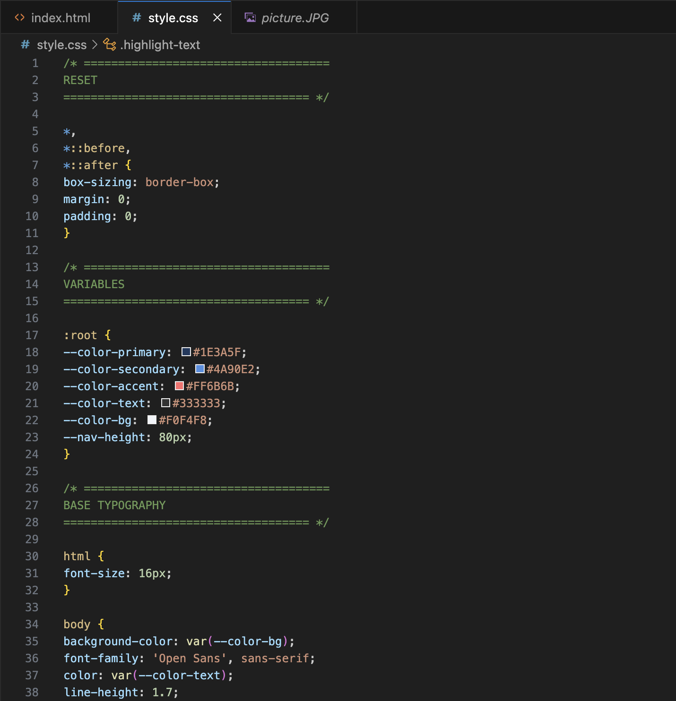
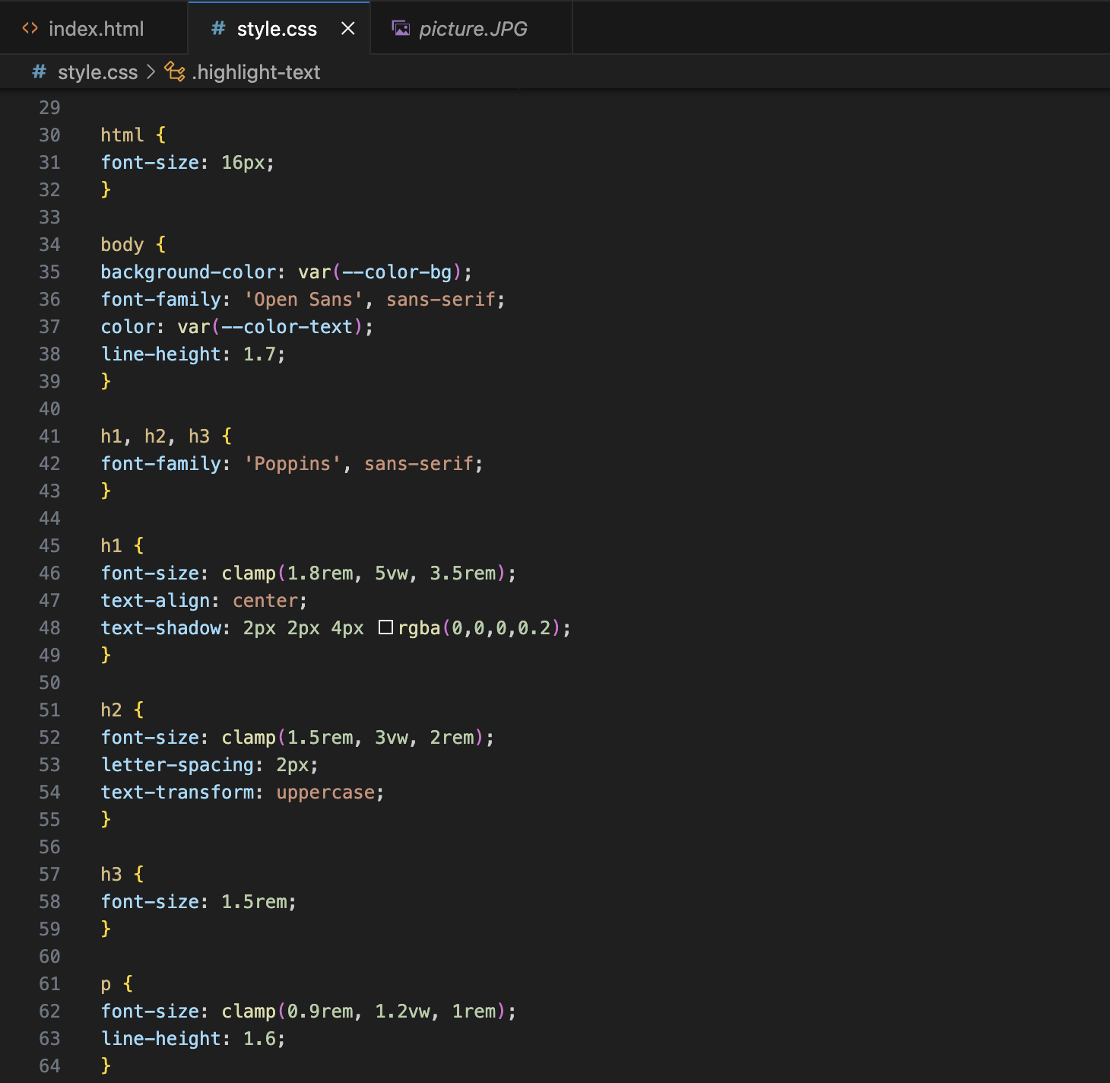
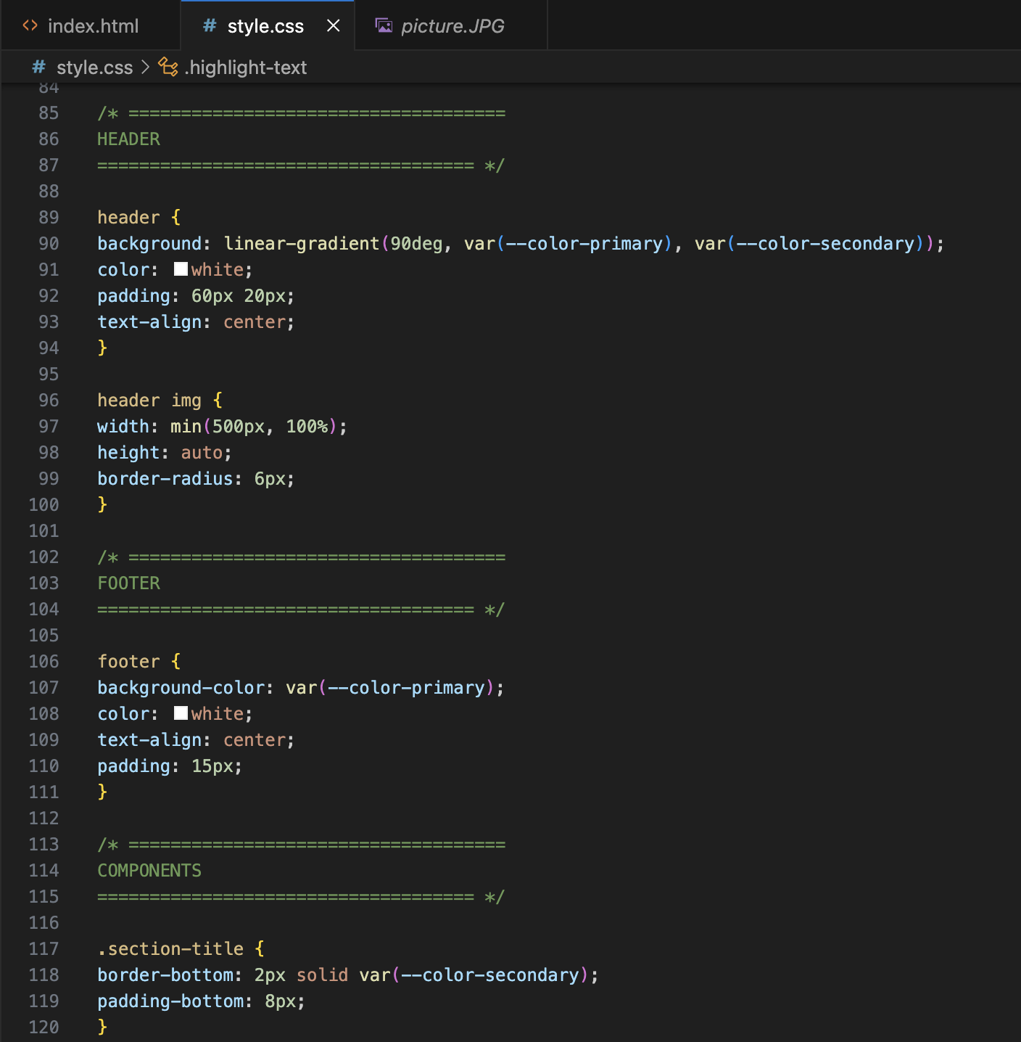

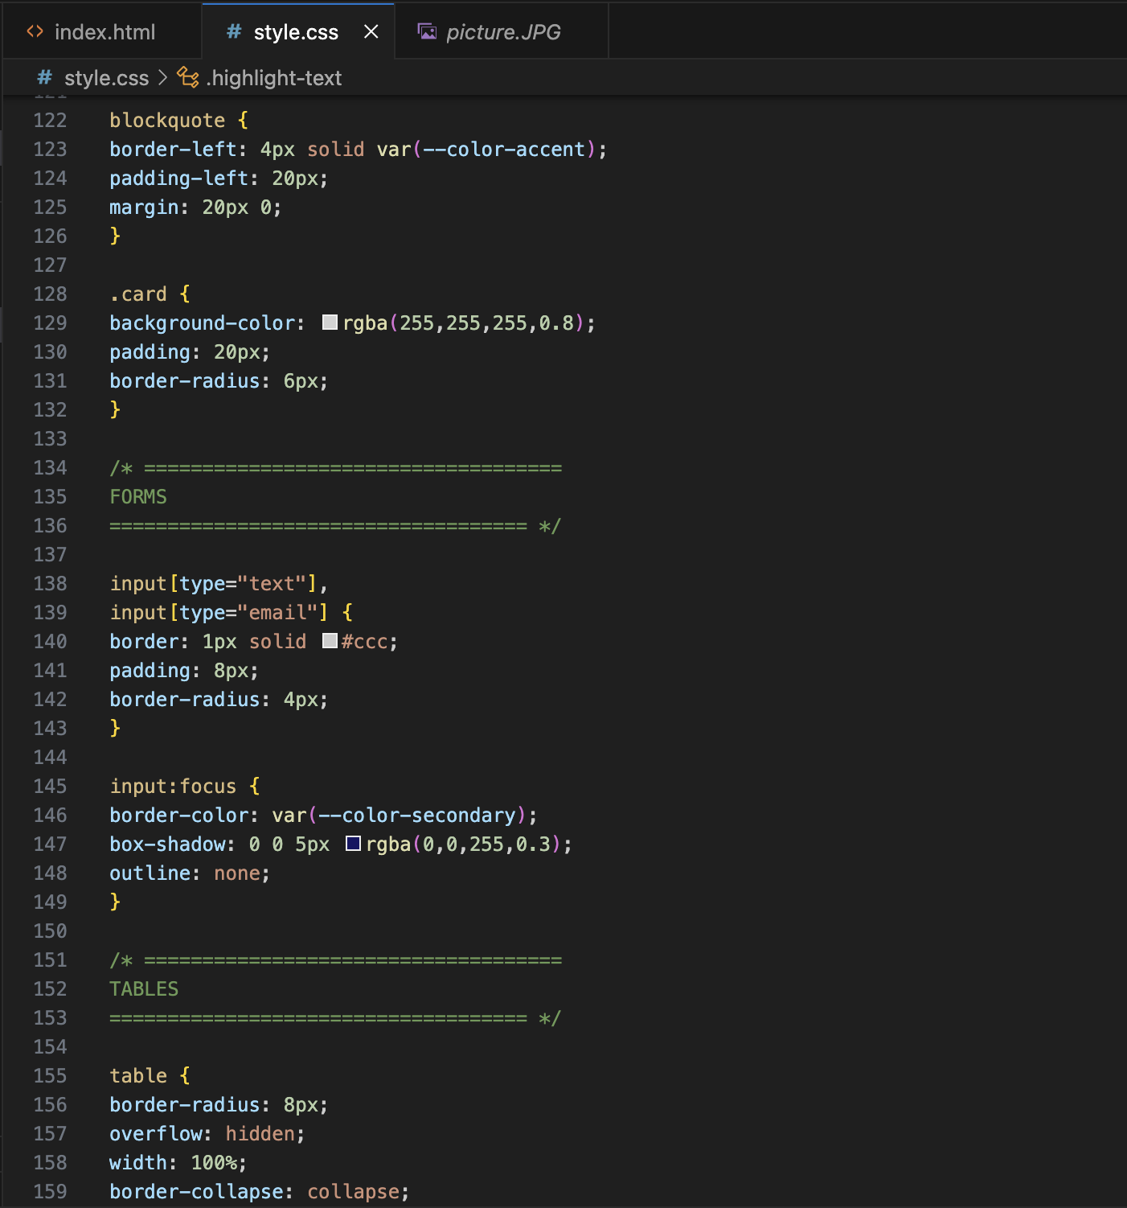
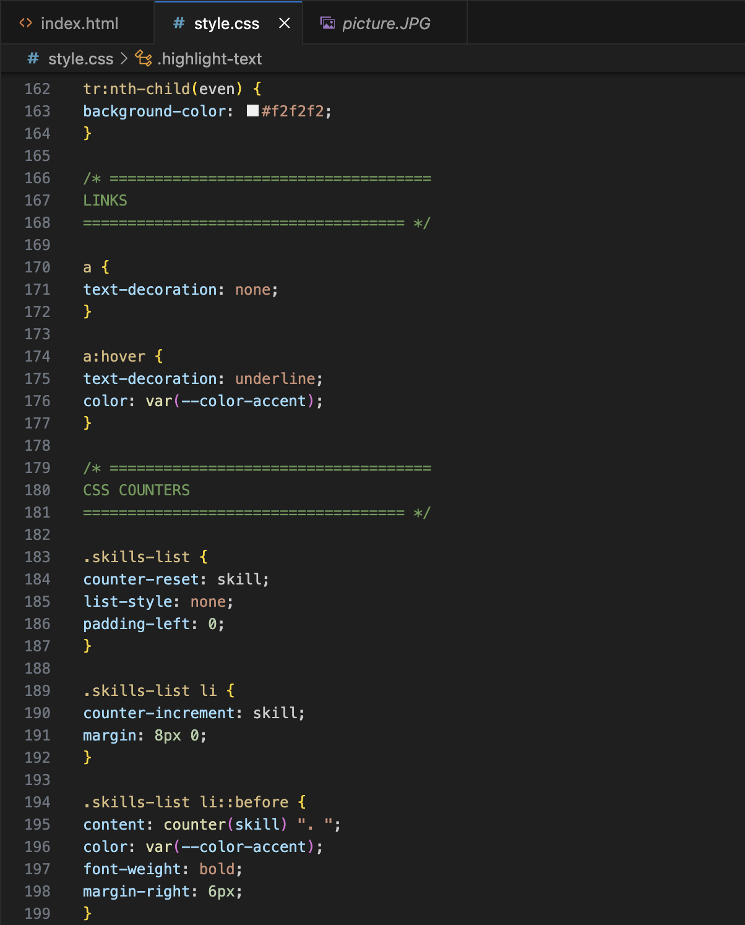
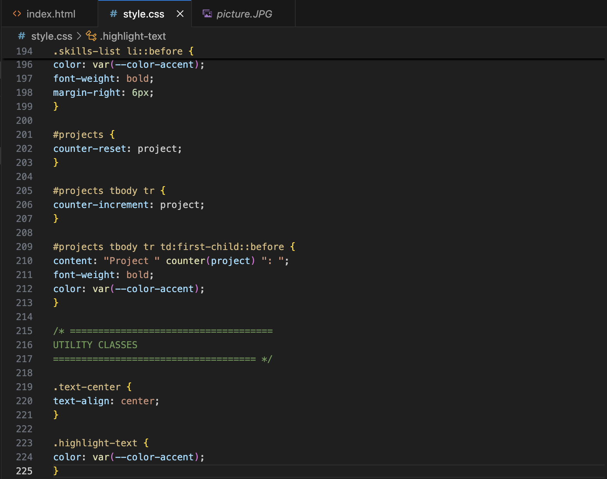
-I optimized my CSS by organizing the stylesheet into clear sections such as reset, variables, typography, layout, and components. This improves readability, removes duplicate declarations, and ensures reusable CSS variables are used throughout the design.

Exercise 11: Make Your Portfolio Accessible
- Check your color contrasts at webaim.org/resources/contrastchecker. Ensure all text meets 4.5:1 ratio.
- Replace any * { outline: none; } with a proper :focus-visible style.
- Add the prefers-reduced-motion media query at the bottom of your CSS to disable animations for users who prefer it.
- Ensure body text is at least 16px and line-height is at least 1.5.
- Make sure links are distinguishable from normal text even without color (use underline or bold on :hover).
- Run your page through the axe DevTools extension or the Lighthouse accessibility audit in Chrome DevTools.

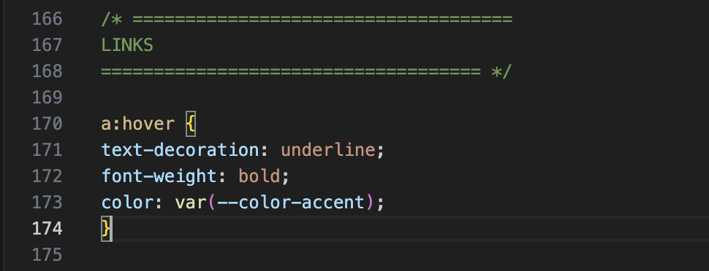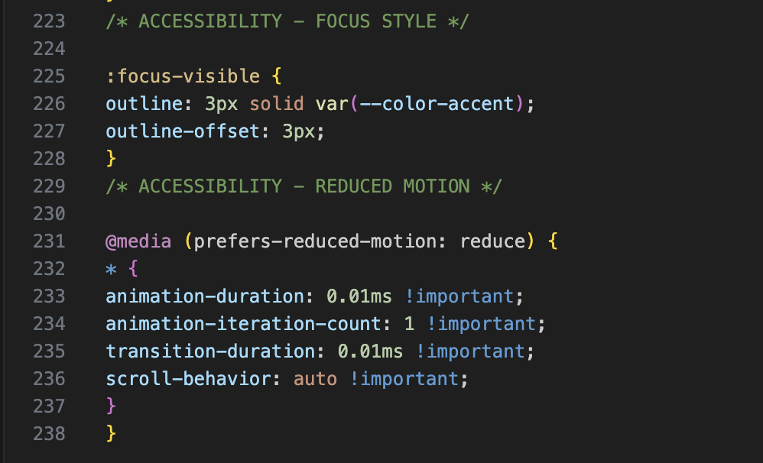
-I improved accessibility by adding a visible :focus-visible outline for keyboard navigation, supporting the prefers-reduced-motion media query, ensuring readable text sizes, and making links distinguishable from regular text.

Exercise 12: Add Comprehensive Hover Effects to Your Portfolio
- LINKS: Add the full LVHA rule set (a:link, a:visited, a:hover, a:active) to your stylesheet with distinct colors for each state.
- NAV: Add the slide-in underline effect to your nav links using nav a::after with width transitioning from 0 to 100% on :hover.
- CARDS: Apply the lift effect to all project cards — transform: translateY(-8px) and deeper box-shadow on :hover, with transition on the base state.
- BUTTONS: Add at least two button hover styles — one solid (color shift) and one outline (fill on hover). Add :active to simulate a press.
- IMAGES: Wrap your profile photo in a div.img-wrapper. Apply overflow: hidden and scale(1.08) on hover so the image zooms inside its container.
- SKILL TAGS: Apply the pill hover effect — background flips to primary color, text turns white, slight scale(1.07) on hover.
- TABLE ROWS: Add tr:hover td background highlight and test it in your projects table.
- PROJECT CARDS: Add a .overlay div inside one project card. On :hover, the overlay slides up or fades in showing project details.
- Pair all :hover rules with matching :focus-visible rules for keyboard accessibility.
- BONUS: Use CSS variable overriding on :hover to change multiple child elements with a single parent hover.
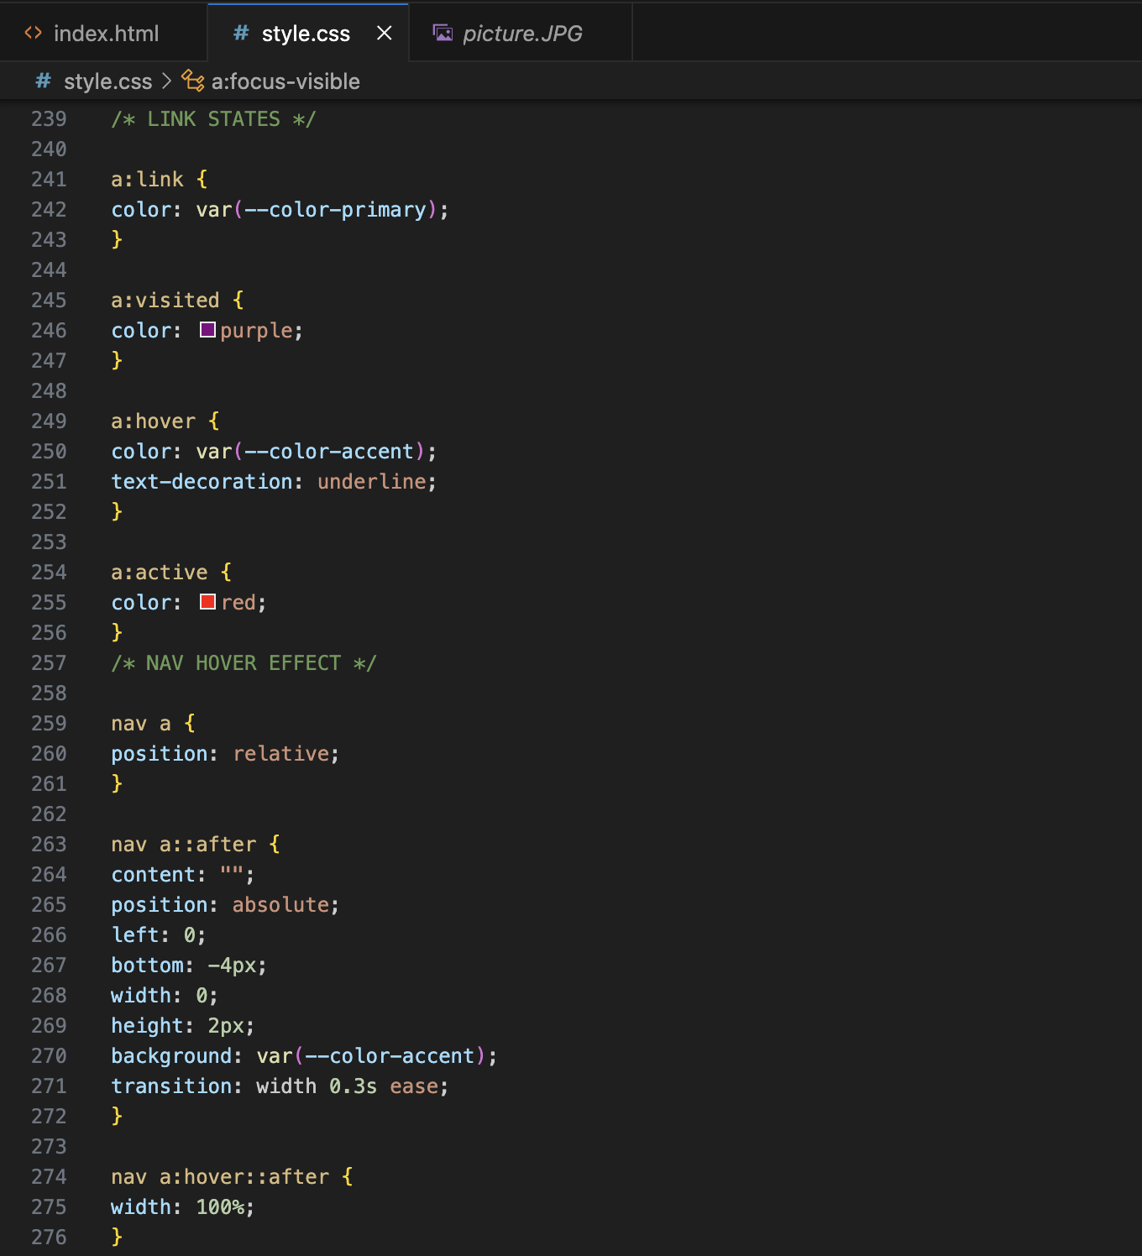
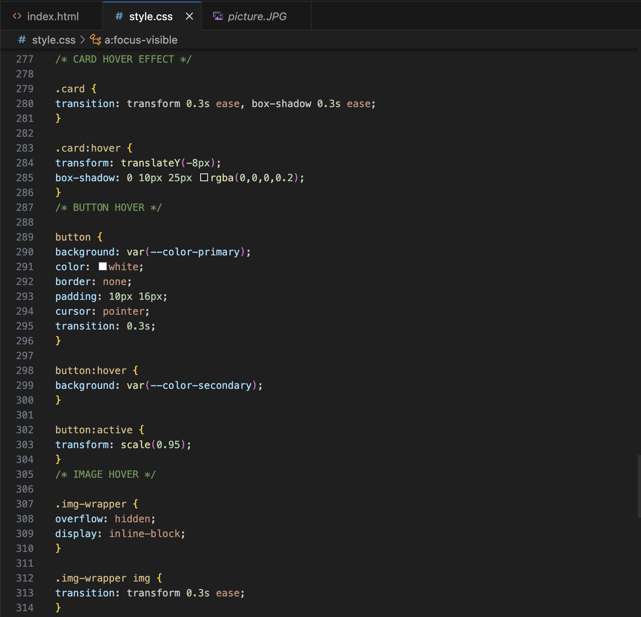
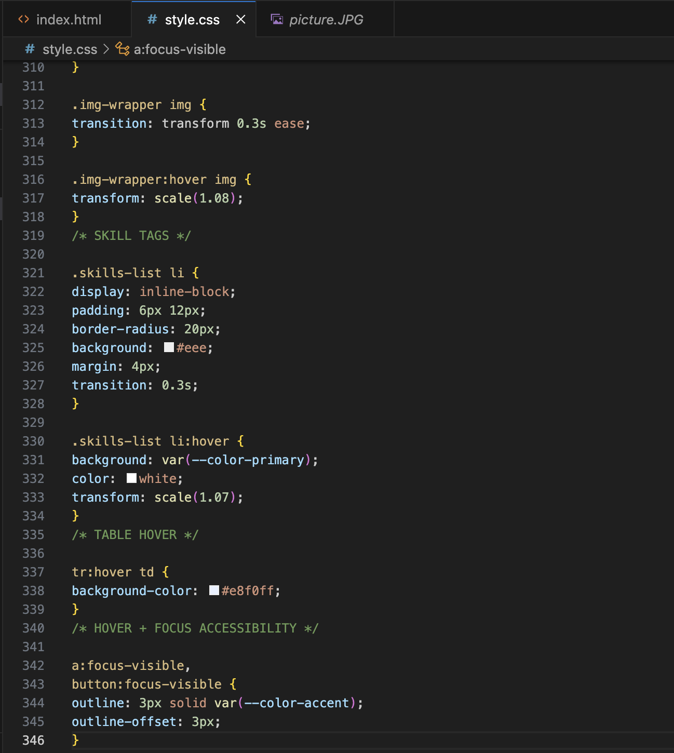
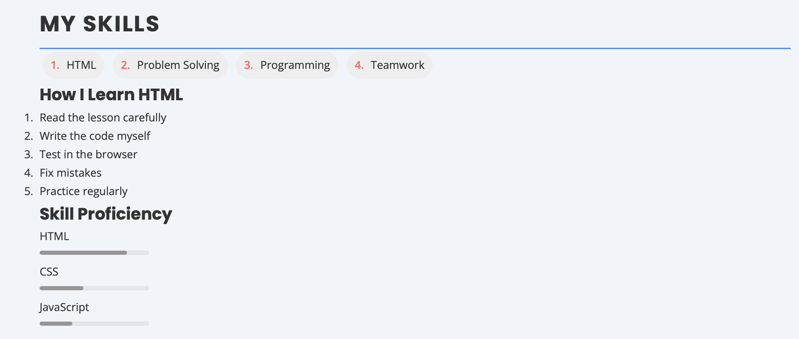
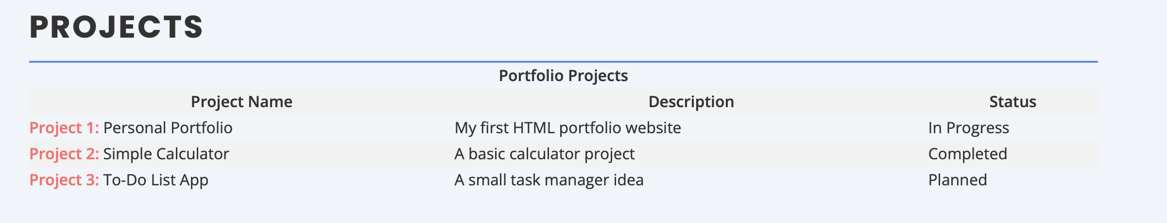
-I implemented multiple hover effects including link states, navigation underline animation, card lift effects, image zoom interactions, and table row highlighting. These effects improve user interaction and visual feedback while maintaining accessibility through matching focus styles.

